Serious games for active learning in Optimization of Chemical Processes
Ismael Díazª, Emilio J. Gonzálezª, María González-Miquelª, Manuel Rodríguezª
ªDepartamento de Ingeniería Química Industrial y del Medio Ambiente, Universidad Politécnica de Madrid, C/ José Gutiérrez Abascal 2, Madrid 28006, Spain
ismael.diaz@upm.es
Abstract
Optimization of Chemical Processes is a course that demands a thorough understanding of mathematical concepts and intensive use of programming tools. In recent years, new cohorts of students have shown a decreased interest and motivation for the subject. To mitigate it, a modification of course activities is proposed based on active learning methodologies. These methods have previously demonstrated a positive impact on students’ engagement and motivation. In this work, active learning is implemented by means of serious games, offering additional advantages such as a positive impact on the work climate and teamwork collaboration, among others. This paper details three examples of serious games, ranging from simple word search games (aimed at fostering the remembering and understanding of important concepts) to complex escape room activities (designed to address open problems and promote students’ creativity).

Keywords: Optimization, active learning, serious games
  - Introduction
The primary objective of this study is to show the efforts made to improve Gen Z students’ motivation towards the subject Optimization of Chemical Processes taught at Universidad Politécnica de Madrid (Spain). In the last years, a decrease in student’s engagement and motivation was perceived leading to a shift towards a more active approach by the incorporation of serious games. The main novelty of this work is presenting some examples of how serious games of variable complexity can be used to address the previous issues. In sections 1.1 and 1.2 the problem is presented along with the expected impacts of introducing serious games. Section 2 is fully devoted to describing the activities developed and implemented. Key findings are presented in Section 3 and the final conclusions in Section 4.
    - Characteristics of the new generation of students (Gen Z)
The present higher education landscape witnesses a marked shift in the characteristics of students compared to previous generations like Baby boomers, Gen X, and Gen Y. Generation Z is the term coined to describe people born between 1995 and 2010, whose identity has been built based on the ubiquitous access to internet and a pervasive use of social media with a fast access to a vast amount of information. The latter, along with the rise of global problems such as climate anxiety and the shifts in the financial and labor markets, have greatly influenced their behavior and preferences (Billings et al., 2016). Young people today are defined, among others, by their increasing interest in the sustainability and green transition, being more socially inclusive and showing more concerns about mental health, coupled with a pragmatic decision-making approach and a desire for immediate feedback. Unfortunately, these distinctions with respect to previous generations of students are usually overlooked in the design of higher education courses, which could be one of the reasons behind the disaffection of Gen Z students with the higher education system.
Contrary to the assumption of being the first “native digital generation”, Generation Z students generally exhibit limited technological proficiency, many of them being reluctant to programming or using scientific software. Precisely, the intensive use of algebraic programming and mathematics is the main characteristic of the course Optimization of Chemical Processes analyzed in this paper. This fact, exacerbated by the impact of the COVID19 pandemic, has resulted in a perceived worse students’ motivation in the last years which has affected students’ learning and performance. On the other hand, following ABET recommendations, it is important to foster not only analytical and problem-solving learning, but it is also necessary to promote soft skills such as teamwork and communication among others.

    - Serious games and active learning
To address the identified challenges, an effective teaching approach is the implementation of active learning methodologies (Rodríguez et al., 2018), understood as instructional methods that engage students in the learning process.
An active learning methodology helping to address previous issues is the use of serious games, defined in 1970 by Clarck C. Abt “as games that have an explicit and carefully thought-out educational purpose and are not intended to be played primarily for amusement” (Abt, 1970). The theoretical foundations of using game-based learning are well established (Krath et al., 2021). It has been observed to positively impact people’s behavior, cognitive skills, and motivation. According to the existing literature some key game design aspects have been identified (goals, feedback, social play, etc.) being the root for three different games designed and implemented in the course (word search, a conference-like activity, and the escape room). For the interested reader, more details about the advantages of using serious games in chemical engineering courses can be found in our recent paper (Díaz et al., 2024).
For the specific course on Optimization of Chemical Processes, a range of activities has been formulated based on Bloom’s taxonomy (Figure 1). Foundational-level activities focus on recall and comprehension, utilizing crossword games to revisit previously taught concepts. These activities, conducted throughout the semester, served the purpose of revisiting specific concepts previously taught. Moving towards the application of the knowledge, a conference-like activity has been developed. In this activity, students are required to set new exercises regarding different real life problems, not restricted to chemical engineering applications, also participating as co-evaluators of other students, thus forcing them to analyze other’s solutions. The exercises are submitted in a paper format, there is a review process and finally their work is presented in a poster session. Finally, an activity requiring high level thinking was implemented at the end of the semester in the form of a modular escape room. In this activity, students must solve different quizes regarding general concepts but also formulate and solve diverse optimization problems, leveraging programming skills cultivated during the course. In all the activities, game-based elements were added in order to foster competition, challenge and teamwork, positively impacting student’s engagement and the work climate in the classroom. As it can be seen in Figure 1, the role of the teacher in the activities is also evolving during the semester. At the beginning, the teacher plays an important role presenting concepts, tools, etc., giving more prominence to the students as the course progresses. In the last activities, students are in the center of the learning process being responsible for their own learning (creating problems, analyzing solutions, etc.).

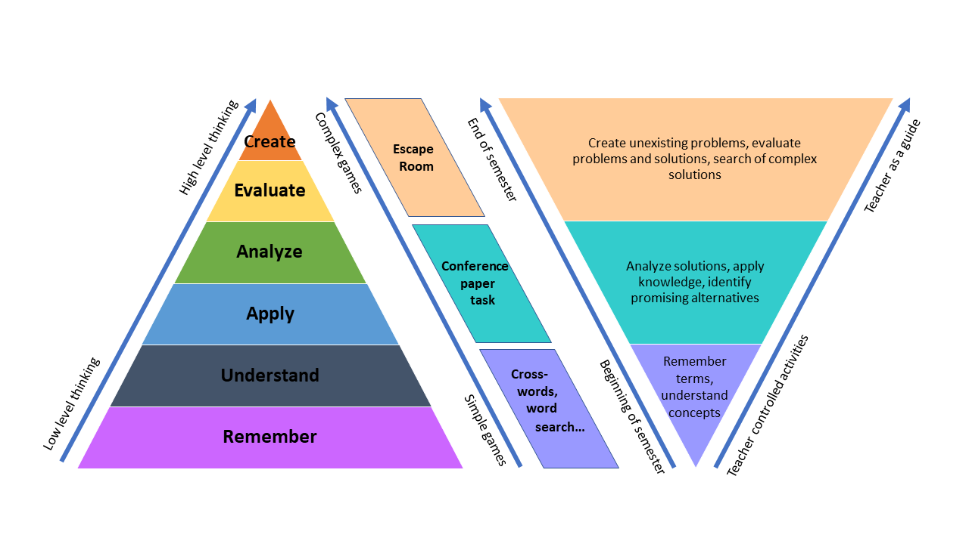
Figure 1. Context of the games developed according to Bloom’s taxonomy, adapted from Díaz et al. 2024.
  - Implementation of serious games in Optimization of Chemical Processes

    - The non-gamified subject
The course Optimization of Chemical Processes is taught as a compulsory course during the first semester of the master’s degree in chemical engineering (Universidad Politécnica de Madrid, Spain). Students attending this course have very different process system engineering (PSE)-related backgrounds, depending on the university they come from. Many of them have not used any programming software in the last years. The number of students is normally between 25-30.
Prior to the COVID19 pandemics, the course structure involved a combination of master classes and practical sessions. At the beginning of the semester some general concepts (convexity, optimality, etc.) were presented along with the programming tool (Python/Pyomo). Subsequently, a block about linear programming and mixed-integer linear programming was introduced in the syllabus, where the students delved into the main algorithms (simplex, branch and bound, etc.) and problems (transport, allocation, diet, etc.). Afterwards, the students explored the non-linear block where, again, general concepts, algorithms and problems were worked during the lessons. The last segment introduced advanced concepts such as mixed integer non-linear programming and multi-objective optimization methods.

    - Simple games to promote remembering and understanding.
At the end of crucial lessons, simple games were created to reinforce important concepts (an example is presented in Figure 2). In the non-gamified course, revisiting concepts was done by dedicating 10-15 min of each lesson for re-teaching the concepts. Now, the same time is dedicated to a competition for the fastest student to solve the game. The result is that students are actively looking for previous concepts in their mind, trying to find as many of them in the shortest time, instead of being passive listening the same concepts again. Another advantage from these games is that students are obtaining instant feedback of the concepts they may have missed. Both winning and non-winning students benefit from this approach, as non-winning students pay more attention to the explanation about the concepts they may have overlooked, contributing to a more effective learning experience.
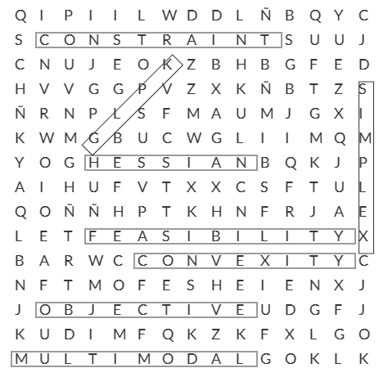
Figure 2. Example of word search.
    - A conference-like activity to apply knowledge and identify real problems.
Throughout the semester, students are tasked with solving many problems (simpler at the beginning, becoming more difficult during the semester) whose objective is to become proficient in using algebraic modelling tools (Python/Pyomo). The Python environment was chosen because of the great number of resources available to learn and solving problems and being open source. However, it is important for them to know that optimization is used in many different real-life situations. Therefore, a task was scheduled where they played the role of PSE professionals attending a conference.
In pairs, the students are firstly required to present an original optimization model they have devised. The constraints are that the problem must be original, and it can be solved using the methods and tools worked during the course. Teachers then evaluate the models proposed based on criteria such as difficulty and originality, marking them as “rejected” (the students must completely re-do the task to pass it), “major revisions” (the student mark is going to be between 5-6.5 out of 10), “minor revisions” (mark between 6.5-8) and “accepted” (8-10).
Two weeks later, the conference takes place, where the students are required to bring a poster to the classroom to share the problem and solution with the rest of “professionals” attending the conference. For one hour, students interact with each other, asking questions and making explanations. Finally, both students and teachers evaluate each poster considering both poster design and oral communication skills. The final grade of each pair of students (each poster) is the result of averaging teacher and other students mark within the limits of the initial range provided. For instance, if a pair obtain a designation of “major revisions” but they deliver a compelling poster presentation, their mark will be close to 6.5, but if they do not convey the message properly, they will obtain a 5.

    - An escape-room to foster creativity
Attending to Bloom’s taxonomy, the highest level of cognitive skills is obtained when an individual can evaluate and create new problems. This is the aim of the escape room designed to be implemented in the last session of the course. Traditionally, this last session was devoted to solving exam-like problems and go over the main concepts of the course. Now, this session is dedicated to face the students to incomplete problems in the form of quizzes, evaluating the way they can set new optimization problems from restricted information. This escape-room also allows teachers to gauge the extent to which students are adept at solving problems using the subject's tool.
The game is designed to be modular. Initially, each team receives a red box, common to all groups, which contains another box inside. The outer box is initially secured with a chain and a code lock (shown at the top left in Figure 3). The groups also received a letter providing the context of the story. This letter contains the information to solve an initial linear programming whose solution is the numerical code needed to unlock the red box. Inside it, they find different quizzes and items that provide the constraint of an incomplete problem (mixed integer programming). The correct solution of the new problem is again the numerical code needed to open a smaller box. Once the second box is opened, teams encounter theoretical questions and a puzzle related to the classical problem classification tree of optimization problems. The ordered sentence derived from the solution is obtained, and instructions are provided for problem number 3. The solution (temperature 479.73 K) corresponds to the positions of letters in the ordered sentence (4 =P, 7 =X, 9 =K, 7 =X, 3 =M). The final code is obtained by applying a decoder to the previous code.

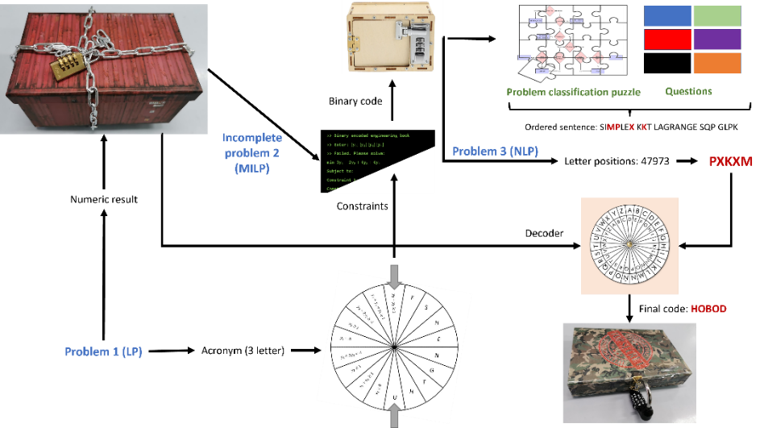
Figure 3. Escape room designed for the last session of the course, adapted from Díaz et al. 2024.
  - Results
At the end of the semester, students are asked to participate in a global survey regarding both the subject and the instructors. As it can be seen in Figure 4, the subject global mark reached a minimum during the course 2020/2021 which can be attributed to the shift to remote teaching methods used amid the pandemics. During the following two courses, some serious games were gradually introduced in the subject, what seems to be welcomed by the students according to the results obtained. However, there is not a clear trend on the mark given to the teachers. The results from students’ survey also show that they perceive game-based activities as more motivating. This is especially important for the case of students who did not keep the subject up to date. In previous years, these students usually “disconnected” from the course activities and the group, being more prone to work alone. The introduction of game-based activities based on group collaboration encourages them to continue working because they want to participate in the activities. It is important to highlight that all the activities were designed with a try-fail-try again philosophy. Teachers do not intend to use these activities for grading the students (evaluation activities are the same in the gamified and non-gamified approaches), but rather to encourage students to attempt the activities, get the feedback, learn from experience and then do it again.
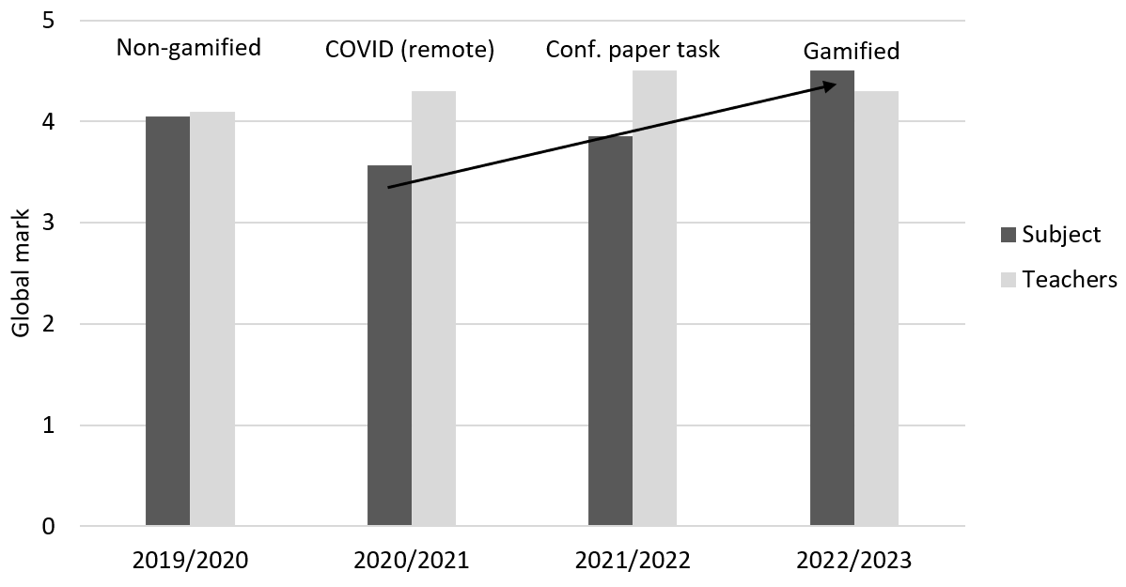
Figure 4. Results of the students’ survey about the subject and teachers. Marks are between 0 (very poor) and 5 (excellent).
  - Conclusions
In the last years, a disengagement and reduced motivation of students in the subject Optimization of Chemical Processes was perceived. To address this issue, this paper proposes a solution through the implementation of active learning methodologies. Three examples of serious games have been presented, rooted in the Bloom’s taxonomy and the theoretical basis of game-based learning. As a result, simple word search games were implemented to foster low level skills (remember and understand). In contrast, a conference-like activity and an escape room game were applied in the last lessons of the course with the aim of stimulate critical thinking, problem solving and creativity.
Acknowledgement
The authors are grateful to Universidad Politécnica de Madrid for funding the projects IE23.0506 and IE22.0509.
References
Abt, C.C., 1970. Serious Games. American Behavioral Scientist 14, 129–129. https://doi.org/10.1177/000276427001400113
Billings, D. M., Kowalski, K., Shatto, B., Erwin, K., 2016. Moving on From Millennials: Preparing for Generation Z. The Journal of Continuing Education in Nursing, 47(6), 253–254. doi:10.3928/00220124-20160518-05
Díaz, I., González, E.J., González-Miquel, M., Rodríguez, M., 2024. Application of serious games in chemical engineering courses. Education for Chemical Engineers 46, 22–32. https://doi.org/10.1016/j.ece.2023.10.002
Krath, J., Schürmann, L., Von Korflesch, H.F.O., 2021. Revealing the theoretical basis of gamification: A systematic review and analysis of theory in research on gamification, serious games and game-based learning. Computers in Human Behavior 125, 106963. https://doi.org/10.1016/j.chb.2021.106963
Rodríguez, M., Díaz, I., Gonzalez, E.J., González-Miquel, M., 2018. Motivational active learning: An integrated approach to teaching and learning process control. Education for Chemical Engineers 24, 7–12. https://doi.org/10.1016/j.ece.2018.06.003

